REPORT JUNE 03

|  |  |  |  |
| --- | --- | --- | --- |
| Date: | 03-06-2020 | Name: | Bhoomika Hebbar |
| Course: | Digital Design Using HDL | USN: | 4AL17EC010 |
| Topic: | EDA Playground Online compiler , EDA Playground Tutorial Demo Video , How to Download And Install Xilinx Vivado Design Suite ,  Task for Day-3 | Semester & Section: | 6th SEM A sec |
| Github  Repository: | bhoomika_python |  |  |

|  |
| --- |
| FORENOON SESSION DETAILS |
| Image of session |
| **INVERTER:** A power **inverter**, or **inverter**, is a power electronic device or circuitry that changes direct current (DC) to alternating current (AC). The input voltage, output voltage and frequency, and overall power handling depend on the design of the specific device or circuitry.  **Implement Inverter Using The EDA Tool:**  module inverter(y,a); output y;  input a; assign y=~a; endmodule  Testbench Code  timescale ins/lps |

|  |
| --- |
| module testbench(); reg a1;  wire y1;  inverter inv1(a1,y1); initial begin  a1=a’b1;  $display(“a=%b”,a1);  end endmodule  2.RCC: A **ripple counter** is an asynchronous **counter** where only the first flip-flop is clocked by an external clock. All subsequent flip-flops are clocked by the output of the preceding flip-flop. Asynchronous **counters** are also called **ripple**-**counters** because of the way the clock pulse **ripples** it way through the flip-flops.  Ripple Carry Counter  module ripple_counter_4_bit(q,clk,reset); input clk,reset;  output[3:0]q;  T_FF tff0(q[0],clk,reset); T_FF tff1(q[1],q[0],reset);  T_FF tff2(q[2],q[1],reset);  T_FF tff3(q[3],q[2],reset); endmodule  module T_FF(q,clk,reset); input clk,reset;  output q; wire d;  D_FF dff0(q,d,clk,reset); not n1(d,q);  endmodule  module D_FF(q,d,clk,reset); input d,clk,reset;  output reg q;  always@(negedge clk or posedge reset) begin  if(reset) q<=1'b0;  else q<=d; end  endmodule  TestBench Code  module test  reg clk,reset; wire(3:0)q;  ripple_carry_counter rcc(q,clk,reset);initial begin |

# $dumpfile(“dump.vcd”);

$dumpvars(1,test); clk=1’b0; reset=1’b1;

#10 reset=1’b0;

#200;

end

always #5 clk=~clk; endmodule

Implement 4 to 1 MUX using structural modelling style and test the module in an online/offline compiler.

library IEEE;

use IEEE.STD_LOGIC_1164.ALL;

entity mux2_1 is

port(A,B : in STD_LOGIC; S: in STD_LOGIC;

Z: out STD_LOGIC);

end mux2_1;

architecture Behavioral of mux2_1 is begin

process (A,B,S) is begin

if (S ='0') then Z <= A;

else

Z <= B;

end if; end process;

end behavioral;

library IEEE;

use IEEE.STD_LOGIC_1164.ALL;

entity mux4_1 is port(

A,B,C,D : in STD_LOGIC; S0,S1: in STD_LOGIC; Z: out STD_LOGIC

);

end mux4_1;

architecture Behavioral of mux4_1 is component mux2_1

port( A,B : in STD_LOGIC; S: in STD_LOGIC;

Z: out STD_LOGIC);

end component;

signal temp1, temp2: std_logic; begin

m1: mux2_1 port map(A,B,S0,temp1); m2: mux2_1 port map(C,D,S0,temp2); m3: mux2_1 port map(temp1,temp2,S1,Z);

end behavioral;

# Date: 03-06-2020 Name: Bhoomika Hebbar

Course: Python by Udemy USN:4al17ec010

Topic: Build a Web-based Financial Graph Semester & Section:6 th A

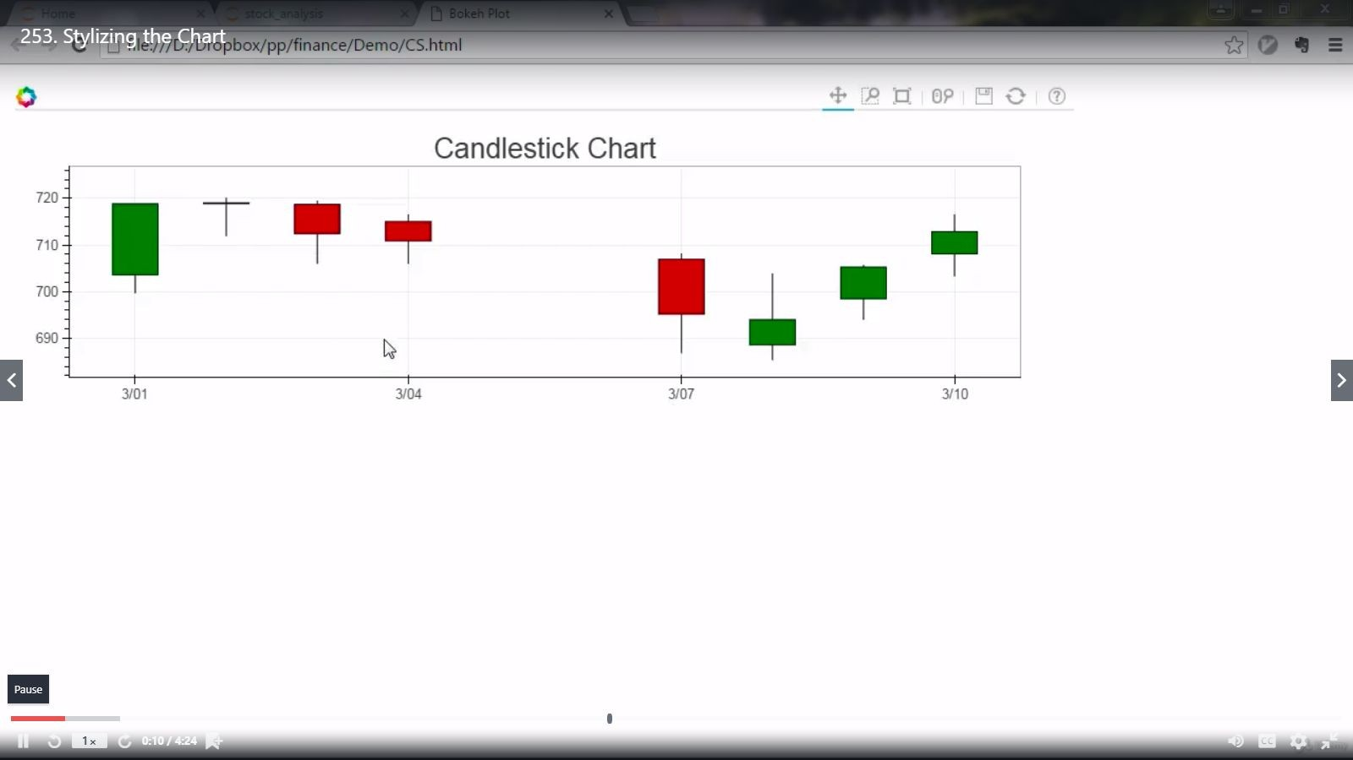

**Image of session:Output**

**AFTERNOON SESSION DETAILS**

# Build a Web-based Financial Graph

from flask import Flask, render_template app=Flask( name )

@app.route('/plot/') def plot():

from pandas_datareader import data import datetime

import fix_yahoo_finance as yf yf.pdr_override()

from bokeh.plotting import figure, show, output_file from bokeh.embed import components

from bokeh.resources import CDN

start=datetime.datetime(2015,11,1) end=datetime.datetime(2016,3,10)

df=data.get_data_yahoo(tickers="GOOG", start=start, end=end)

def inc_dec(c, o): if c > o:

value="Increase" elif c < o:

value="Decrease" else:

value="Equal" return value

df["Status"]=[inc_dec(c,o) for c, o in zip(df.Close,df.Open)] df["Middle"]=(df.Open+df.Close)/2

df["Height"]=abs(df.Close-df.Open)

p=figure(x_axis_type='datetime', width=1000, height=300) p.title.text="Candlestick Chart" p.grid.grid_line_alpha=0.3

hours_12=12*60*60*1000

p.segment(df.index, df.High, df.index, df.Low, color="Black")

p.rect(df.index[df.Status=="Increase"],df.Middle[df.Status=="Increase"], hours_12,

df.Height[df.Status=="Increase"],fill_color="#CCFFFF",line_color="black")

p.rect(df.index[df.Status=="Decrease"],df.Middle[df.Status=="Decrease"], hours_12,

df.Height[df.Status=="Decrease"],fill_color="#FF3333",line_color="black")

script1, div1 = components(p) cdn_js=CDN.js_files[0] cdn_css=CDN.css_files[0]

return render_template("plot.html", script1=script1,

div1=div1, cdn_css=cdn_css, cdn_js=cdn_js )

@app.route('/') def home():

return render_template("home.html")

@app.route('/about/') def about():

return render_template("about.html")

if name ==" main ": app.run(debug=True)